Upward Bound Rhetorical Triangle
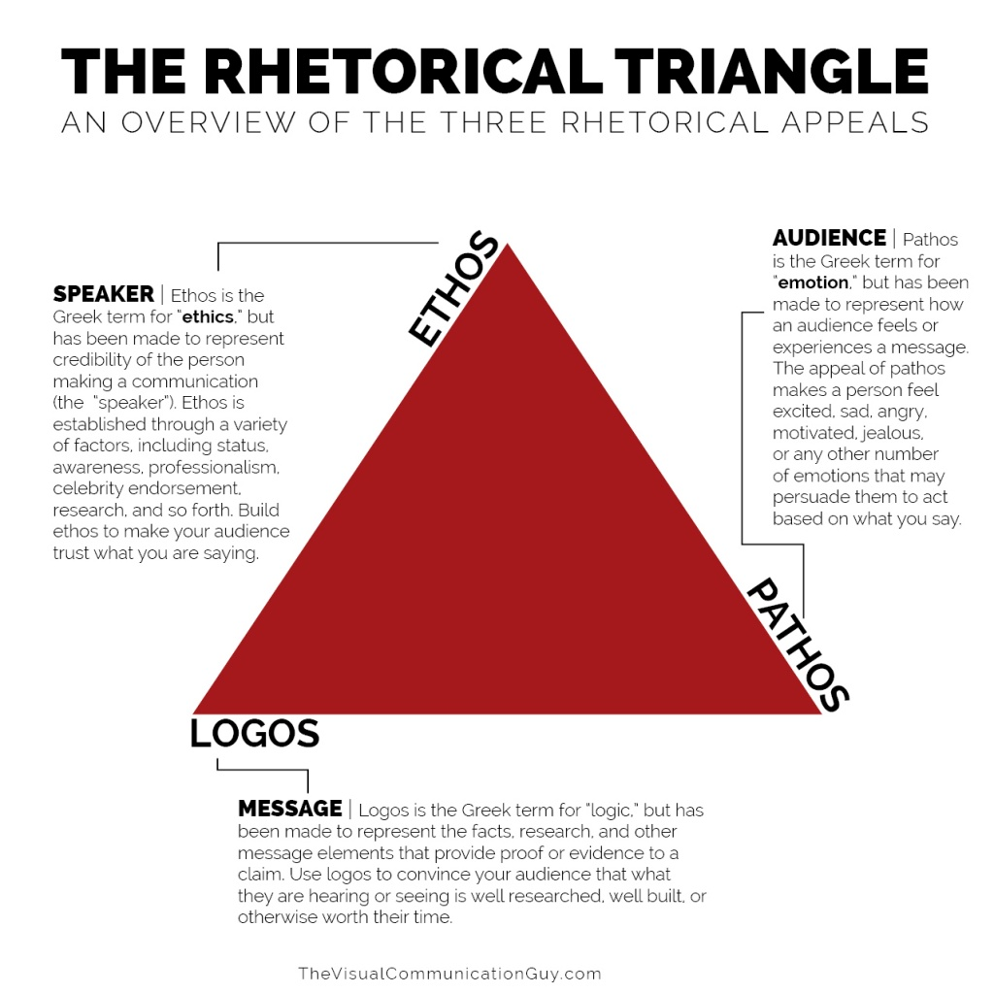
- The above diagram offers a basic outline of the rhetorical triangle, but does not include Kairos-In rhetoric, kairos is "a passing instant when an opening appears which must be driven through with force if success is to be achieved." Kairos is critical portion of the rhetorical triangle, devices. It is often associated with the base of the triangle, because it is a foundation for context.
- Please find a modern example of digital media for whichever device you have been assigned -logos, ethos, pathos, kairos and discuss how the digital image conveys this element of rhetoric. Please bring this to our next class meeting. Be prepared to discuss these digital images and your arguments related to how they represent this device.

